TalentLink and Microsoft Teams Integration

What is the benefit?
When you invite candidates to interview but intend to hold the interviews virtually via Microsoft Teams, with Teams integrated the interview confirmation emails contain a link to the teams interview removing the additional administrative task of setting these up after candidates have selected their slots.

What do we need?
We need to set up a call with someone from your IT department who can be logged into a generic Microsoft account with a Teams Licence. The generic account does not need admin access however the IT person must have access to authorise the generic account TalentLink access.

NOTE:- this must not be a user’s account as all meetings will feed in to this calendar

Setting up the Connection:
We will carry out the following steps whilst on a call as some actions must be taken from the GSA account (myjobscotland Team).

PART 1 – GSA
- Please go to Settings > System Administration > Company Configuration > Smart Meeting Configuration

- Click on +Add New for setting up a new Online Meeting Integration
- Enter a Name for your connection (e.g. MS Teams Online Integration)
- Choose a Type (either MS Teams or Skype)
- Add a description (optional)
- Enter your login*
- Click on USE OAUTH AUTHORISATZION & SAVE

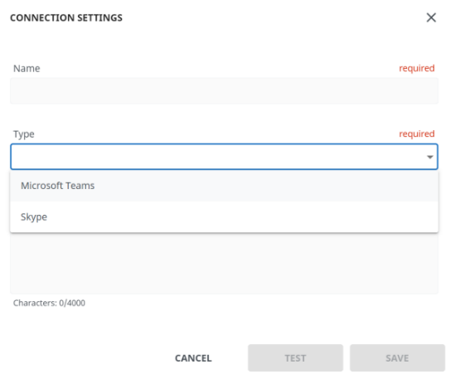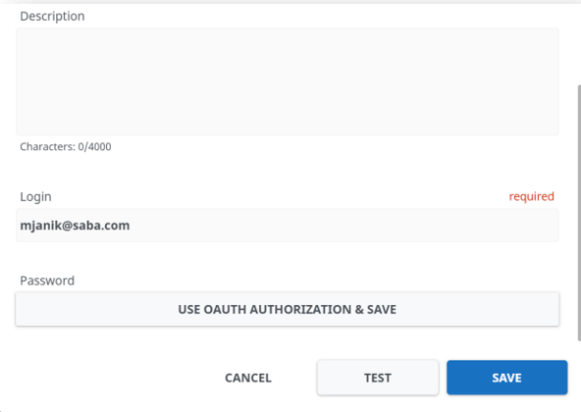

- This will open a new window where the GSA can copy the link and pass it to the appropriate person on the call to use.

PART 2 – ORGANISATION IT
- Need to be logged in to generic email account then follow link provided by GSA to authorisation.
- Depending how IT is set up they may need to submit to admin for authorisation.
- Once authorised link should read 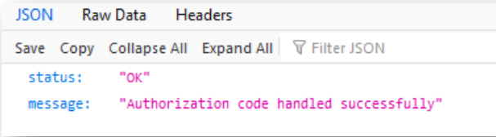

PART 3 – GSA
- Click the TEST button to verify the connection. If the connection is configured properly, you will receive the message Connection succeeded.
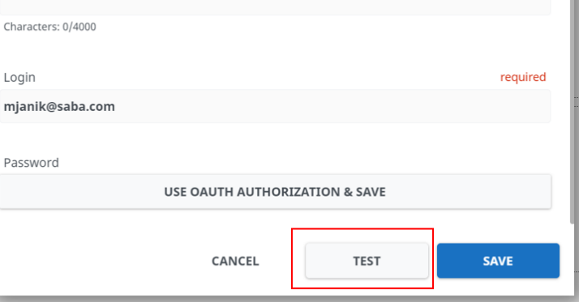

- Once the connection has been set up, please assign the connection as the company default or to one or more organizational units. In order to do so please follow these steps:
  - Select the company default or an organization unit from the dropdown (Set for organization)
  - Select the online meeting connection and click on Save Assignment.
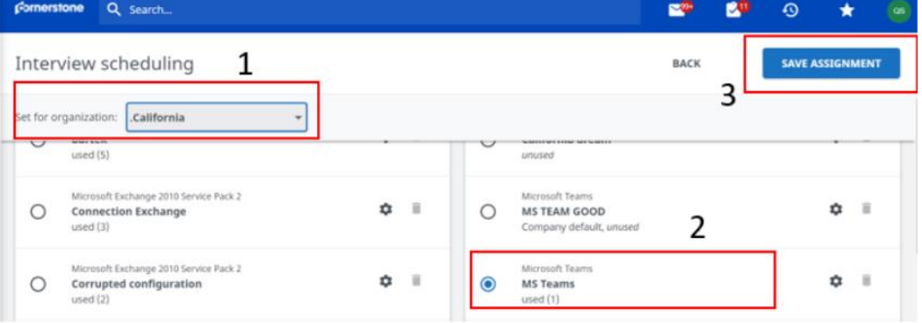

PART 4 – ORGANISATION RECRUITMENT TEAM
- Go to communication templates “Email used in candidate communication”

- Whether you want to edit a current template, create a new or take a copy is up to the individual however once you are in the template you will need to add the meeting link.

You will see a new link on the right-hand side of the template called "Online meeting link". When adding this link you can edit the hyperlink text in a pop-up window.
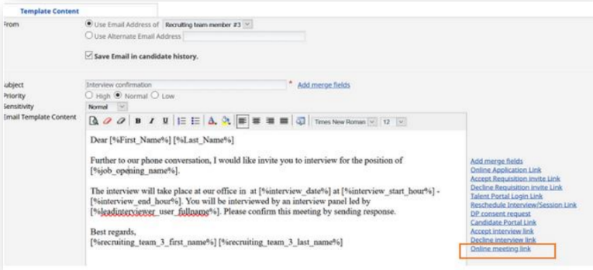

Alternatively, once your template is created, please click on the link “Add merge fields” on the right hand side of the template and select the new merge field called: Online meeting link in the category Selection Process.
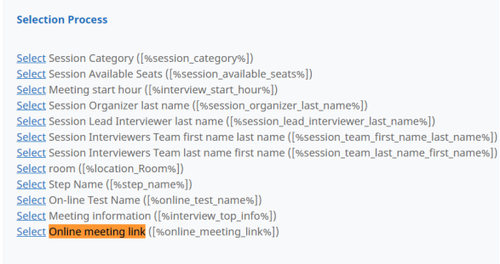
Then you can edit the text "Click here" in the email content: [%online_meeting_link%]Click Here[%/online_meeting_link%]

Please save your template changes.

- Repeat the above for the communication category: “Email used in selection process” so that the online meeting confirmation email containing the link can also be sent to interviewer team.

We would recommend having an interview location called Video Interview or Online Meeting under Settings >System Administration > Corporate Location Management so that this type of meeting is clearly stated in the subject, and no-one shows up at a physical location in error.

