Branding email templates within Talentlink

Email myjobsupport@cosla.gov.uk with a high res image of the logo/image which should be included in the email template. We will then reply with an image code (url.jpg)

How to add an image to a template

- Access email templates via the left hand menu>settings>communication templates;
- Find the template where content should be added or create a new template by clicking ;
- Once you have your template click in the button "toggle source mode" ;
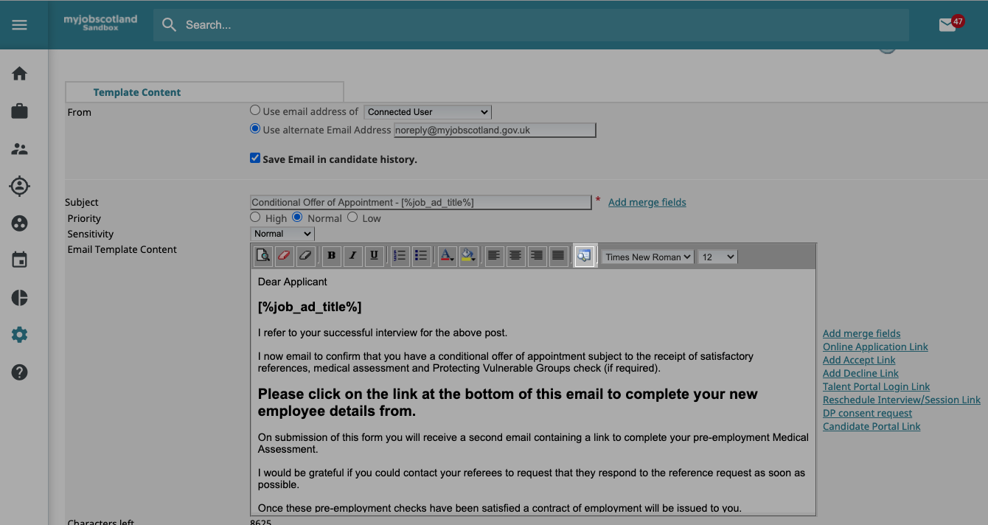

- To add a picture and brand your email template you will now need to add the following HTML code <img src="url.jpg"> an example is shown below;
<img src="https://emea5-static.lumessetalentlink.com/emea5-repository/Mzk2MEBfQC9pbWFnZXMvYWE2NTMzMzAxOTE5OWYzNzZjODY3YzA5Y2ZlMDExZmQucG5n.png?0"> ;
- Replace the text highlighted in yellow with the URL provided by myjobsupport ;
- Click "toggle source mode" icon to return to normal view. You will now see your image and can enter the body of the email.
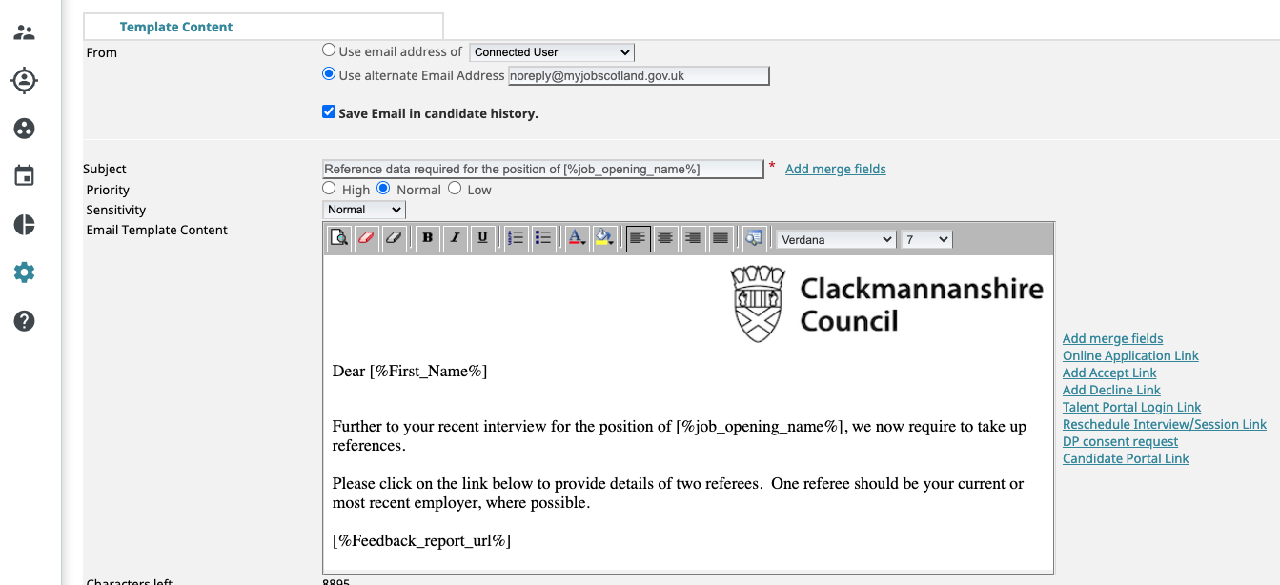
- Click the save icon in the bottom right of the screen to save your updated template.

